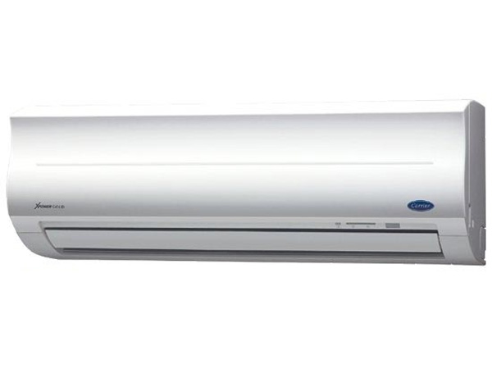

**8.780.000đ**

**Air conditioner Carrier 38/42 CER 013 12,000BTU Gas R410A**

* Type of air conditioner1 pm
* Usable area20m2 - 30m2
* Installation typeWall mounted
* ControlHave
* Inverter technologyAre not
* Power Consumption1.100W
* Voltage source220V/50Hz
* Guarantee24 months
* Made inThailand
* Brand originAmerica

**Indoor unit parameters**

* Size of indoor unitWidth x height x depth *(79cm x 27.5cm x 20.5cm)*
* Volume of indoor unit9kg
* Cooling capacity12.000 BTU - 1.5HP

**Outdoor unit parameters**

* Size of outdoor unitWidth x height x depth *(78cm x 55cm x 29cm)*
* Mass of outdoor unit34kg
* Gas usedR410A

**Product information**

## Carrier 38/42 CER 013 air conditioner information

**Carrier 38/42 CER 013** air conditioner has a modern design with soft curves that help accentuate luxury and elegant colors suitable for installation in any space. Wall-mounted installation helps save space effectively.

[Air conditioners with an operating capacity of 1.5 HP](https://meta.vn/dieu-hoa-c1018?franges=1.92) are suitable for spaces with an area of ​​34 to 40m3.

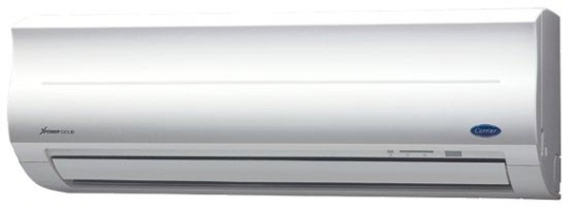

Image of Carrier 38/42 CER 013 air conditioner

The machine has the ability to quickly cool with **10 different wind speeds** to help spread cool temperatures throughout the space. At the same time, you can conveniently adjust the wind direction up and down according to your personal preferences via remote control.

**38/42 CER 013 is equipped with smart timer** capabilities like most modern air conditioners today. Thanks to this function, you can proactively manage the operation of the Carrier air conditioner, even if you fall asleep is no longer a worry.

Besides the cooling ability, [Carrier air conditioners](https://meta.vn/dieu-hoa-c1018?brands=2633) can **kill bacteria well** thanks to Nano Silver Ginseng and Nano Photo Copper filter technology. This is considered one of the most modern air purification technologies capable of preventing bacteria, fine dust,... bringing a fresh, pleasant space for your family.

Another advantage of [Carrier's 1-way air conditioner](https://meta.vn/dieu-hoa-1-chieu-c1039?brands=2633) is the integration of an effective **energy saving** mode . You just need to press the E button on the remote to start this mode.

**>> Reference** :  [How to use the air conditioner control, Carrier air conditioner remote](https://meta.vn/huong-dan/tu-van/cach-su-dung-dieu-khien-dieu-hoa-remote-may-lanh-carrier-9016)

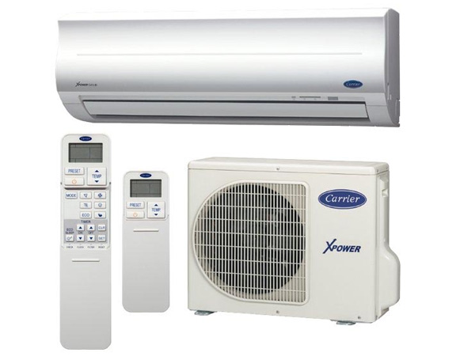

The machine has a remote control

[Carrier 38/42 CER 013 air conditioner](https://meta.vn/dieu-hoa-c1018)  operates stably, cools quickly and smoothly, without affecting your family's activities. While using a Carrier air conditioner, you can enhance the ability to protect the machine by using the **machine malfunction diagnosis mode** to facilitate repair.

The machine is equipped with a remote control.

**>> See details** :  [Which country's Carrier air conditioners and air conditioners are good?](https://meta.vn/huong-dan/tu-van/danh-gia-may-lanh-dieu-hoa-carrier-8980)

**Note:** Product images are for illustration purposes only, product details, colors, designs and specifications may vary depending on the actual product without prior notice.